**REPORT**

**Name: Akshita Jain  
Project Title: Patient appointment no-show rate prediction**

**Problem Overview**:  
No-show appointments are a significant challenge in healthcare, leading to wasted resources and missed opportunities for other patients. This project aims to develop a model that predicts whether a patient will attend their scheduled appointment, enabling healthcare providers to optimize their schedules and reduce inefficiencies.

**Dataset**:  
The dataset contains information about patient appointments, including features like patient age, scheduled time, appointment day, medical history, and past attendance. The data was preprocessed by handling missing values, normalizing continuous features, and splitting it into training and test sets.

**Technology and Methods:**

Three deep learning models were used to predict no-shows:

1. **Feedforward Neural Network (FNN)**: A dense network of layers for structured input data.
2. **Long Short-Term Memory (LSTM)**: A type of RNN that captures time-based patterns, ideal for sequential data.
3. **Convolutional Neural Network (CNN)**: Traditionally used for image data, but here applied to 1D data for feature extraction from sequential patterns.

**Key Findings and Results**:  
The performance of each model was evaluated using accuracy as the main metric:

* **FNN**: Achieved an accuracy of **79.91%**.
* **LSTM**: Achieved an accuracy of **79.88%**.
* **CNN**: Outperformed both FNN and LSTM with an accuracy of **80.02%**.

**Visualization**:  
Graphical visualizations, including comparison charts and confusion matrices, were used to present the results of each model. These plots clearly show how each model performs in predicting no-shows and highlight the comparative effectiveness of the CNN model.

**Use Cases and Benefits**: These models can help healthcare providers predict patient no-shows and optimize appointment scheduling. By identifying high-risk patients, providers can take actions like sending reminders, improving efficiency, and reducing waste.

**Drawbacks**: Despite the relatively high accuracies, the models still face challenges with overfitting, especially on the LSTM and CNN models. They also require substantial computational power and time for training, which may limit their deployment in real-time applications without appropriate hardware.

**Working Example**:  
The project demonstrates the implementation of the three models using Python and TensorFlow/Keras. A simple Python script allows users to input patient data and receive a prediction on whether the patient is likely to show up for their appointment or not.

### ****Introduction****

No-show appointments pose a critical challenge in healthcare systems worldwide, leading to inefficiencies, wasted resources, and missed opportunities for patients who could have utilized the vacant slots. Healthcare providers often struggle to anticipate which patients might not attend their scheduled appointments, resulting in reduced operational efficiency and potential financial losses.

This project explores the phenomenon of no-show appointments using a dataset that includes demographic, medical, and behavioral information about patients. By leveraging data analysis and predictive modeling, the aim is to identify patterns and factors influencing patient attendance. Ultimately, the goal is to develop a reliable model that predicts whether a patient is likely to show up for their appointment.

### ****Dataset Overview****

The dataset contains 14 attributes related to patient appointments:

* **Patient Information:** PatientId, Gender, and Age.
* **Appointment Details:** ScheduledDay, AppointmentDay, AppointmentID, and Neighbourhood.
* **Medical History:** Scholarship, Hypertension, Diabetes, Alcoholism, and Handicap.
* **Communication:** SMS_received (whether the patient received a reminder).
* **Target Variable:** No-show (whether the patient attended the appointment).

### ****Project Objective****

The primary objective of this project is to:

1. **Understand Key Factors:** Identify demographic, medical, and behavioral factors contributing to no-show appointments.
2. **Build Predictive Models:** Develop a machine learning model to accurately predict whether a patient will attend their appointment.
3. **Provide Recommendations:** Offer actionable insights to healthcare providers to reduce no-show rates and optimize scheduling.

### ****Significance of the Study****

Reducing no-show rates benefits both healthcare providers and patients by:

* Enhancing the efficiency of appointment scheduling systems.
* Ensuring better resource utilization, such as the availability of doctors and facilities.
* Improving patient care by reducing waiting times and ensuring timely medical attention for those in need.

### ****1.Installation and Configuration****

### ****Environment Setup****

To successfully run the project, a proper development environment must be set up. This section outlines the required tools, libraries, and dependencies to analyze the dataset and build a predictive model for the no-show problem.

### ****1. Python Version****

Ensure you have Python 3.8 or higher installed on your system. Python provides the flexibility and extensive libraries needed for data analysis and machine learning.

### ****2. Libraries Used****

The project relies on several Python libraries for data manipulation, visualization, and modeling. The key libraries include:

* **pandas:** For data manipulation and analysis.
* **matplotlib:** For creating static, interactive, and animated visualizations.
* **seaborn:** For advanced statistical data visualization.
* **numpy:** For numerical computations.
* **scikit-learn:** For machine learning model building and evaluation.
* **xgboost (optional):** For gradient boosting algorithms (if used in the model).
* **jupyter:** For creating and running notebooks interactively.

### ****3. Development Environment****

* **Jupyter Notebook:** Ideal for interactive development and visualization

### ****Steps to Install Dependencies****

Run the following command to install all required libraries:



### ****Configuration****

### ****1. Loading the Dataset****

The dataset is available in a CSV format (e.g., appointments.csv). To load it:

* Place the dataset in your working directory.
* Use the following Python code to load the data:

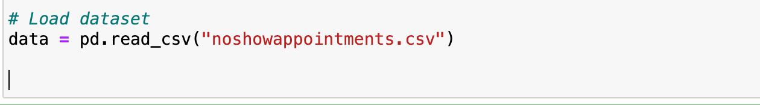

### ****2.Data Analysis and Pre-processing****

Data analysis and preprocessing are crucial steps in preparing the dataset for modeling. This ensures that the data is clean, consistent, and ready for generating meaningful insights or predictions. Below, we outline the steps and provide detailed explanations of the tasks performed.

### ****1. Display Data Structure****

The first step in understanding the dataset is to load and inspect its structure.

* Use the data.head() method to display the first few rows of the dataset. This provides an overview of the columns and their corresponding data.
* Example:

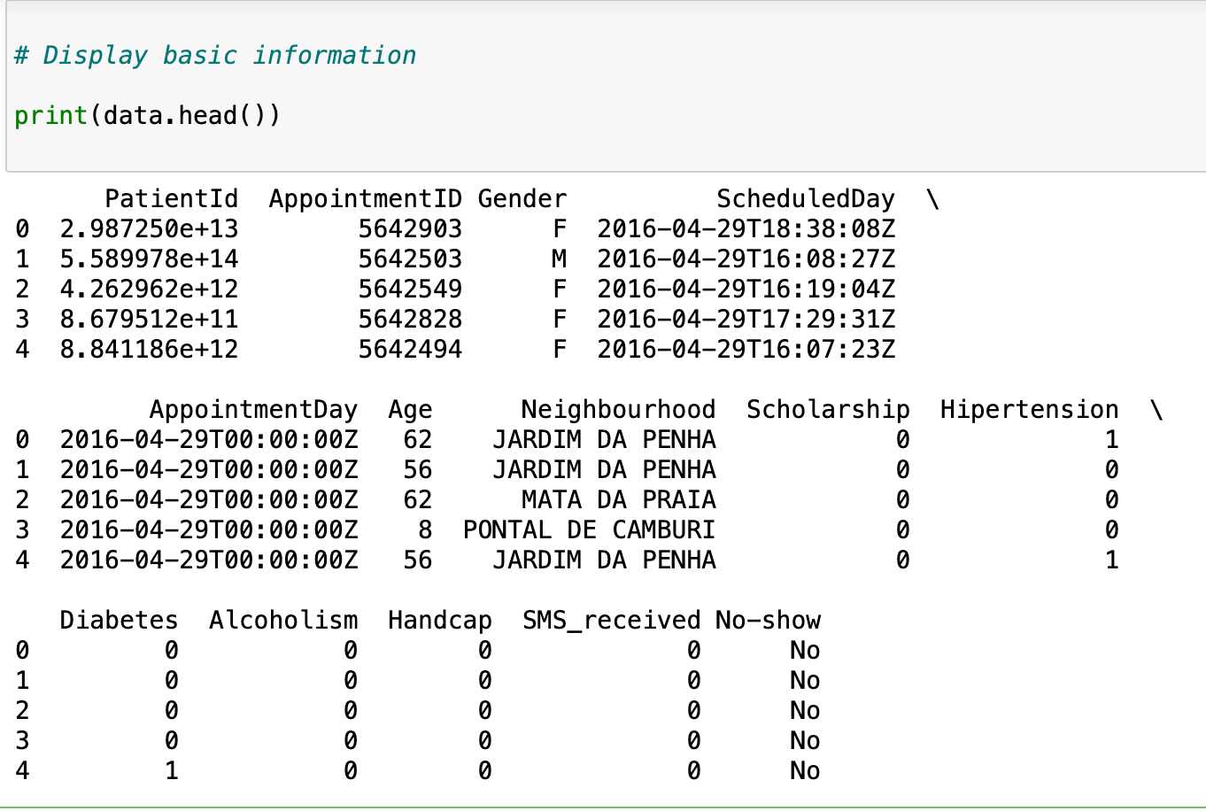

### ****2. Basic Statistics****

Use the data.describe() method to calculate summary statistics (mean, median, min, max, etc.) for numerical columns. This highlights potential issues like outliers or unexpected distributions.

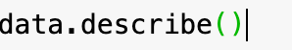

### ****3. Checking Null Values and Duplicates****

Missing or duplicate data can skew analysis and model training. Use the following methods to identify and address these issues:

* Check for missing values:

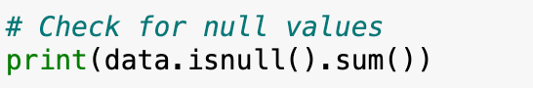

* Check for duplicates:

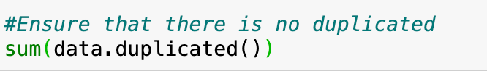

Handle missing or duplicate values as needed (e.g., dropping duplicates, imputing missing values).

### ****Steps for Data Cleaning****

### ****1. Removing Unnecessary Columns****

Some columns may not contribute to predictive modeling or analysis. For instance:

* **PatientId** and **AppointmentID**: While these are unique identifiers, they don't carry any predictive value and can be dropped.



### ****2. Normalizing Data****

Normalization involves standardizing data formats and ensuring consistency across the dataset.

### ****a. Converting Dates****

Columns like ScheduledDay and AppointmentDay are often stored in string format. These need to be converted to proper datetime objects for analysis and feature engineering.

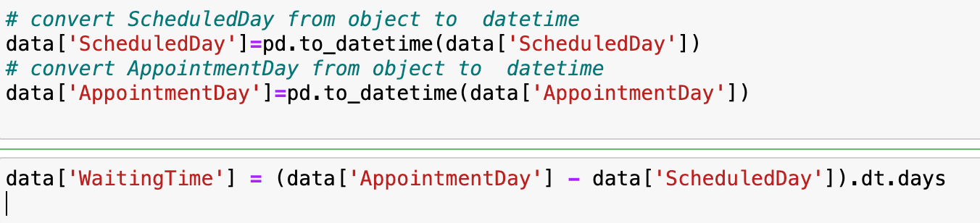

### ****b. Handling Unique Values in Handicap****

The Handicap column might contain values that are unclear or inconsistent. For example:

* Check for unique values:

If the values are numeric but represent categories (e.g., 0, 1, 2), map them to binary values for simplicity (e.g., 0 for no handicap, 1 for any handicap).



### ****3. Identifying Outliers in Age****

Outliers in the Age column (e.g., negative values or extremely high ages) can distort analysis.

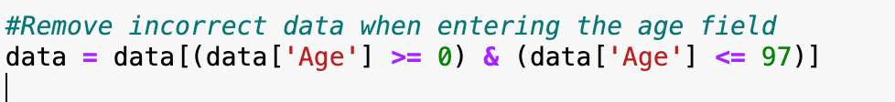

### ****Preprocessing Steps****

### ****1. Renaming Columns for Readability****

Column names should be clear and consistent. For example, Hipertension can be renamed to Hypertension for better clarity.



### ****2.. Encoding Categorical Variables****

### Convert non-numeric columns, such as Gender and No_Show, into numerical formats to make them compatible with machine learning algorithms.





### ****3. Creating a New Feature for Waiting Time****



### ****Benefits of Data Cleaning****

* Improves data quality by removing noise and inconsistencies.
* Enhances the performance of machine learning models by focusing on relevant features.
* Reduces computational overhead by eliminating redundant information.

### ****3. Exploratory Data Analysis (EDA)****

### ****a. General Observations****

* **Attendance Statistics:**
  + **Show-Up Rate:** ~80%
  + **No-Show Rate:** ~20%
  + Visualized with pie charts and count plots.

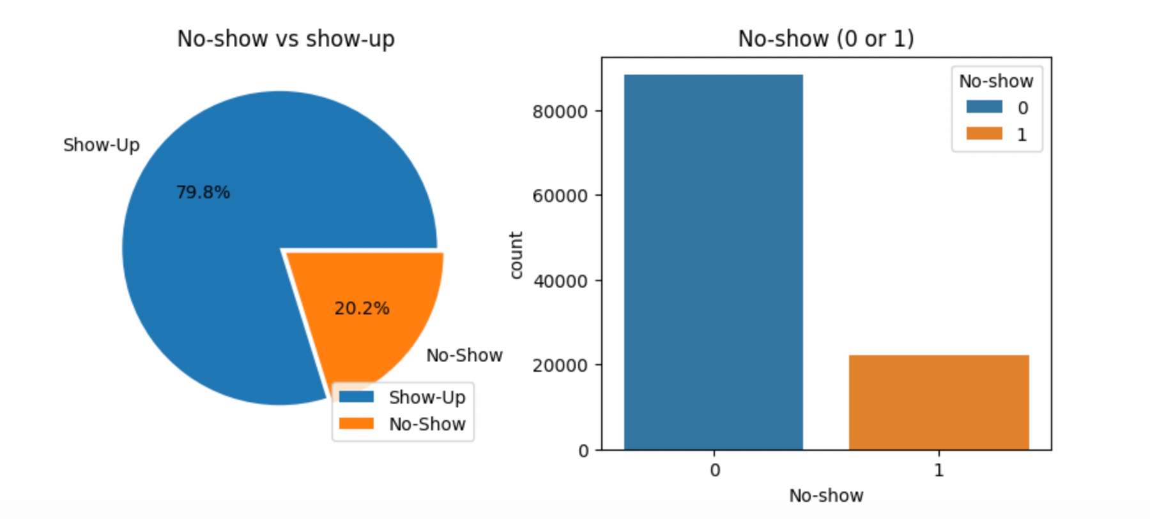

### ****b. Correlation Heatmap:****

* Shows relationships between variables.
* Strongest correlation observed between No-show and WaitingTime.

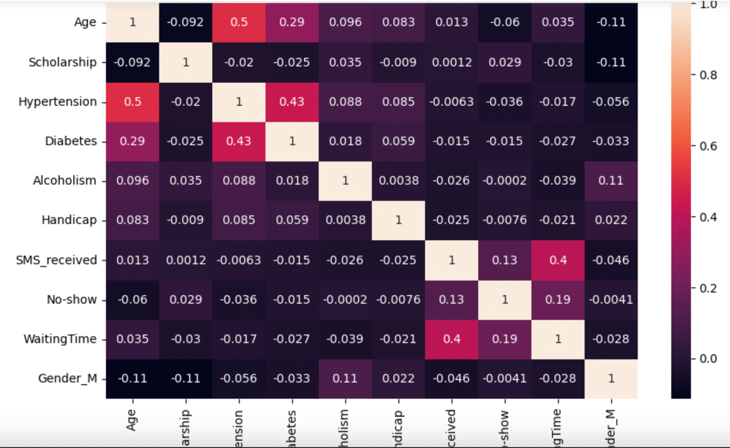

**c. Demographics**

* **Age Distribution:**
  + Majority of patients are between 20 and 60 years old.
  + Average age of no-show patients: **34.3 years**.
  + Average age of show-up patients: **37.8 years**.

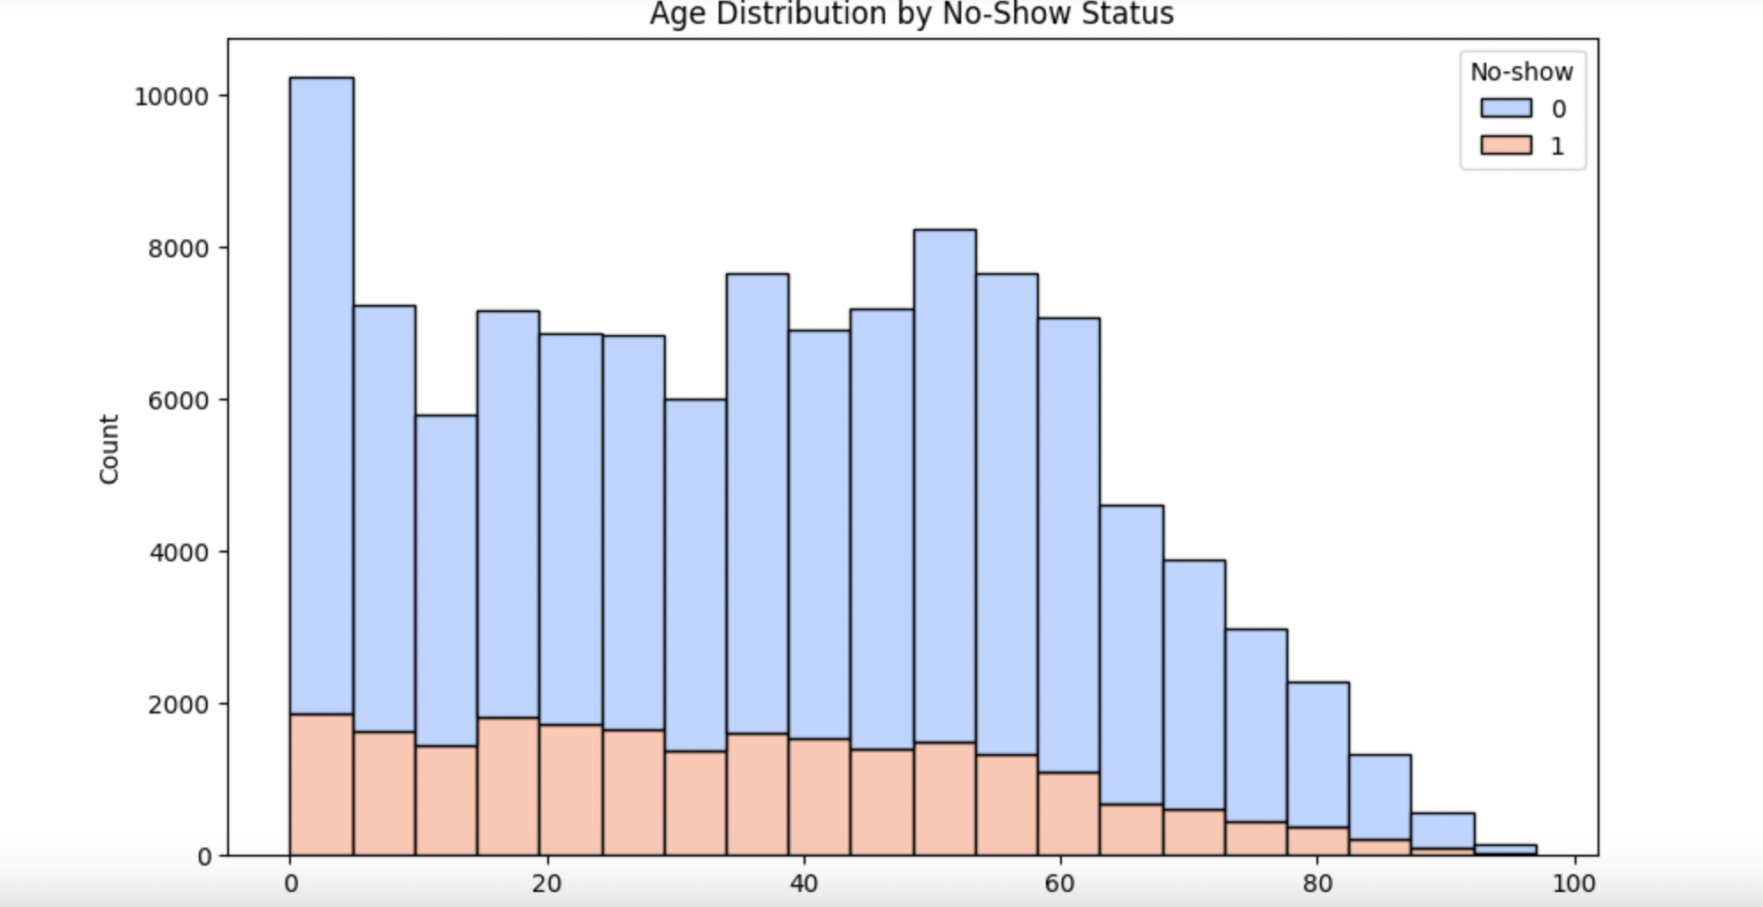

* **Gender Analysis:**
  + Females are slightly more likely to book appointments.
  + No significant difference in show-up/no-show rates between genders.

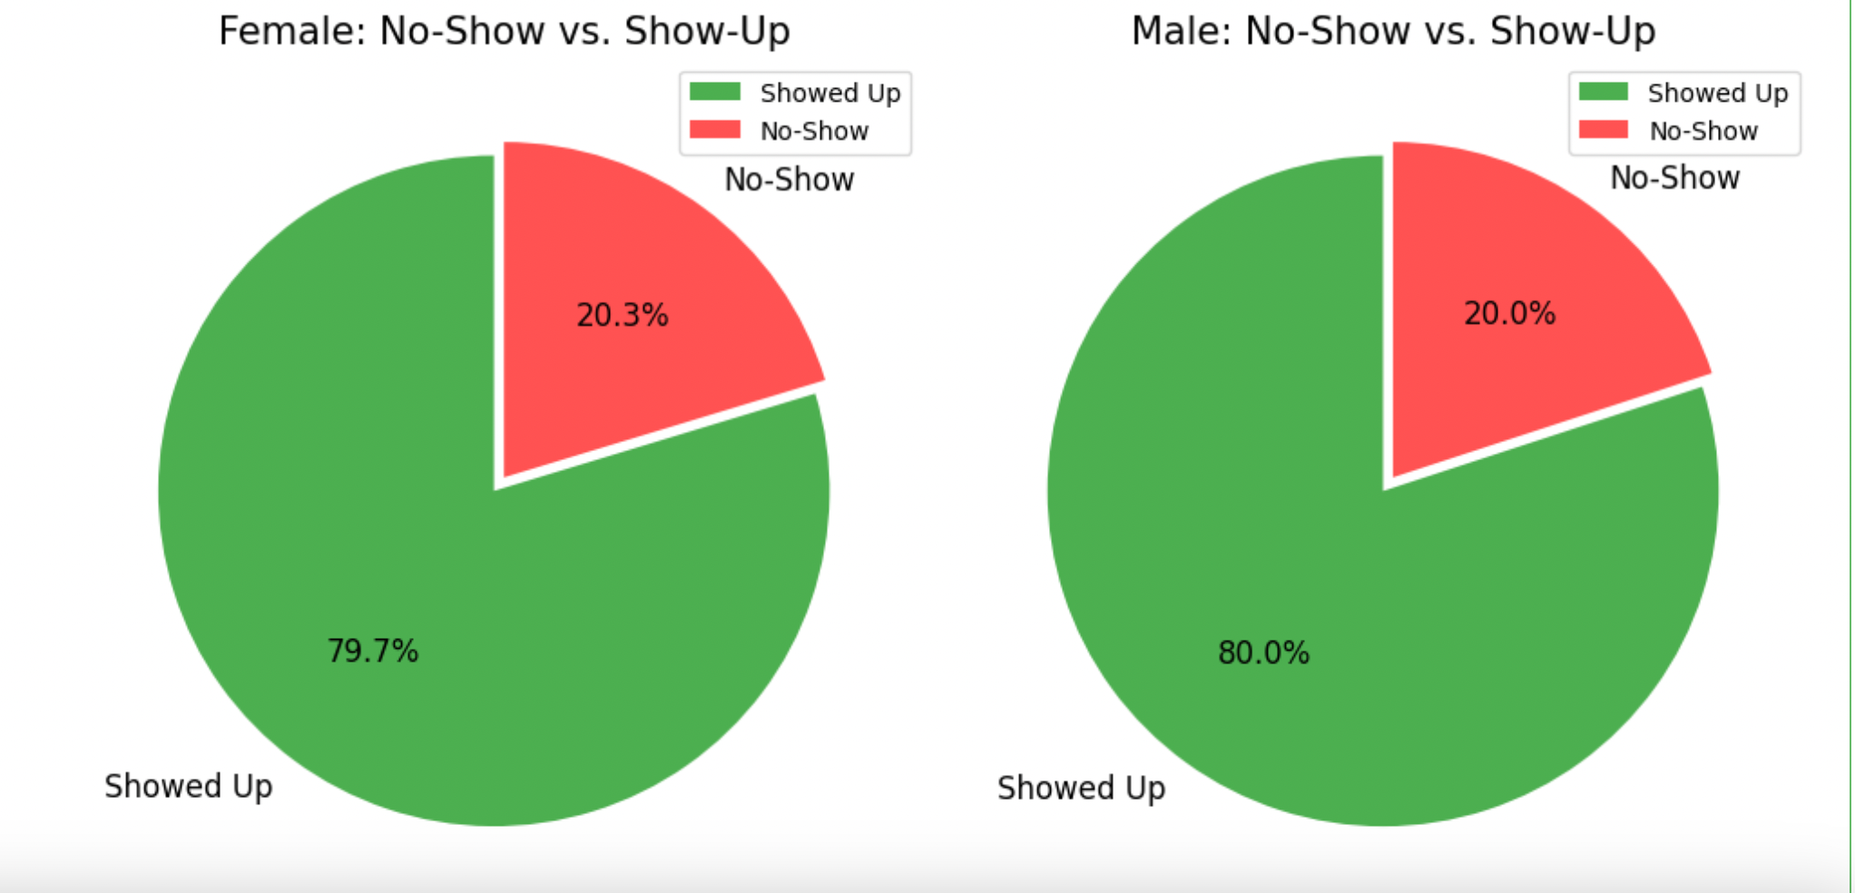

### ****d. Medical Conditions****

• **Hypertension vs No-show** (left):

* Patients without hypertension (Hypertension = 0) are more likely to attend appointments (No-show = 0) compared to those with hypertension.
* The no-show rate for patients without hypertension is higher than that for patients with hypertension, but the total count for Hypertension = 0 dominates.

• **Diabetes vs No-show** (right):

* Similarly, patients without diabetes (Diabetes = 0) significantly outnumber those with diabetes in both categories (show and no-show).
* The no-show rate is lower for patients with diabetes compared to those without diabetes, although the total population of diabetic patients is small.

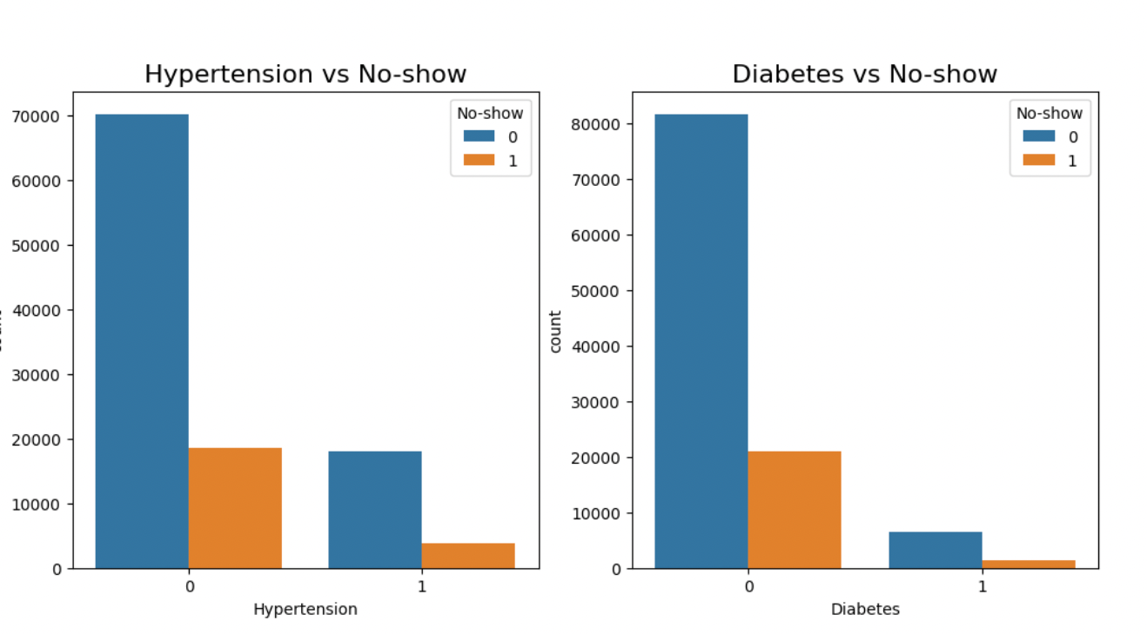

### ****e. Waiting Time****

This boxplot shows the relationship between waiting time (in days) and appointment attendance (No-show status):

• **No-show = 0 (Did not show up)**:

* The median waiting time is higher for patients who did not show up compared to those who attended.
* There is a wider spread of waiting times, with several outliers extending beyond 150 days, suggesting that longer waiting times might discourage attendance.

• **No-show = 1 (Showed up)**:

* The median waiting time is lower for patients who attended their appointments.
* Most waiting times are short, with fewer extreme outliers compared to those who did not show up.

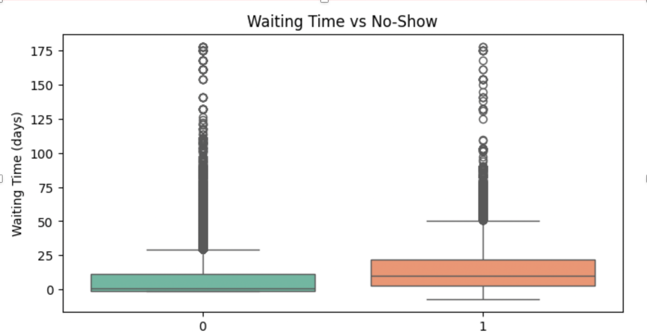

### ****f. Neighborhood Analysis****

* Certain neighborhoods have disproportionately high no-show rates.
* Bar plots show the relative proportion of no-shows across neighborhoods.

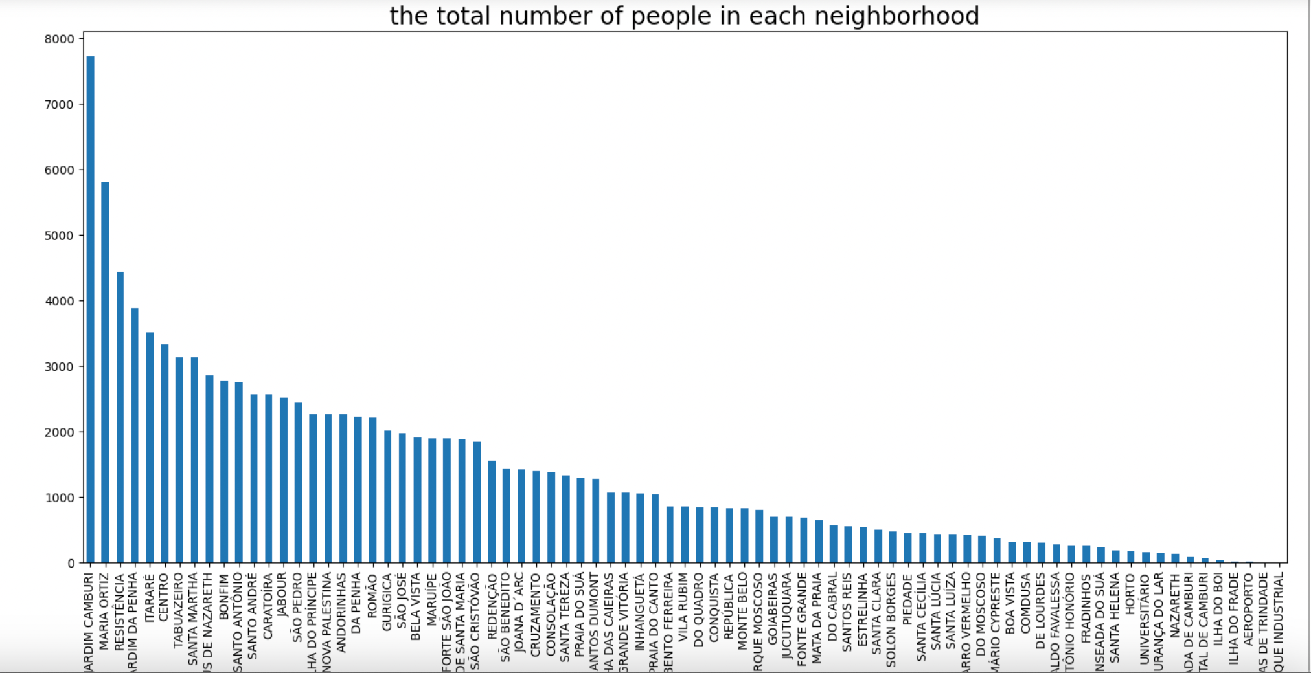

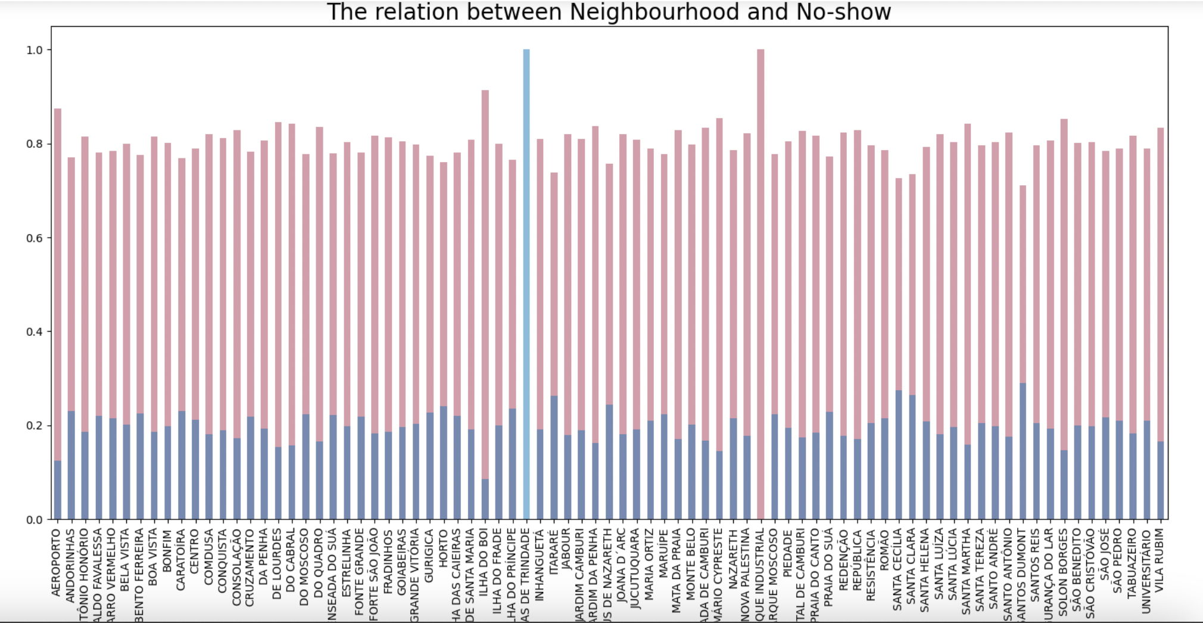

### ****g. SMS Reminder Impact****

* Patients receiving SMS reminders were more likely to show up:
  + No-show rates dropped significantly when SMS reminders were sent.

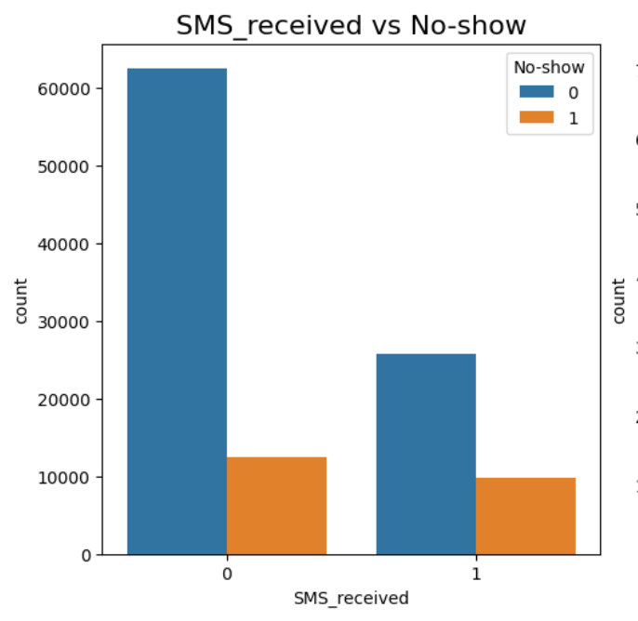

### ****4, Model Building****

### ****1.Splitting Dataset:****

* Input (X) and output (y) variables separated:

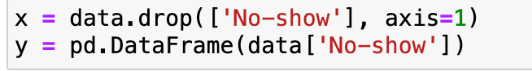

* Divided the dataset into training (70%) and testing (30%) subsets:

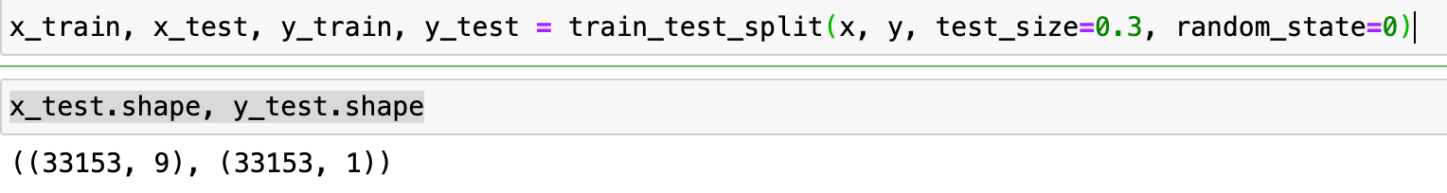

* MinMaxScaler was used to scale features for compatibility with neural networks.

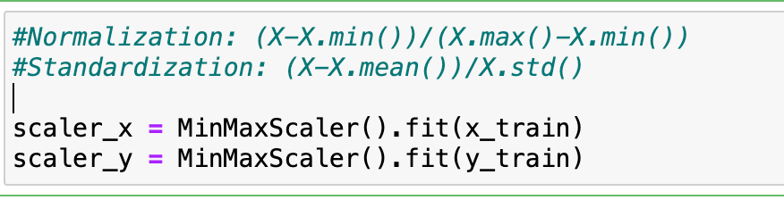

### ****2. Neural Network Models****

Three different architectures were used:

### ****Feedforward Neural Network (FNN):****

* **Architecture:**
  + Input layer (64 neurons) → Hidden layer (32 neurons) → Output layer (1 neuron, sigmoid activation for binary classification).
* **Results:**
  + Training and validation metrics showed a balanced performance with **79.91% accuracy**.

### ****Long Short-Term Memory (LSTM):****

* **Special Processing:**
  + Input reshaped to 3D ([samples, time steps, features]), accommodating the LSTM’s sequential data requirements.
* **Architecture:**
  + LSTM layer (64 units) → Fully connected layer (32 neurons) → Output layer.
* **Results:**
  + Achieved **79.88% accuracy**.

### ****Convolutional Neural Network (CNN):****

* **Special Processing:**
  + Input reshaped to 3D ([samples, features, 1]), suitable for Conv1D.
* **Architecture:**
  + Two convolution layers (64 and 128 filters) → Flatten layer → Fully connected layers → Output layer.
* **Results:**
  + Slightly better with **80.02% accuracy**.

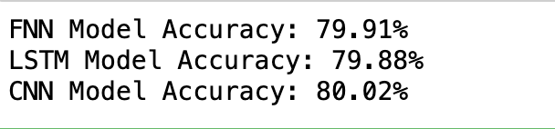

### ****5. Evaluation Metrics****

### ****Confusion Matrix:****

* + Clearly displayed True Positives, True Negatives, False Positives, and False Negatives for each model using heatmaps.

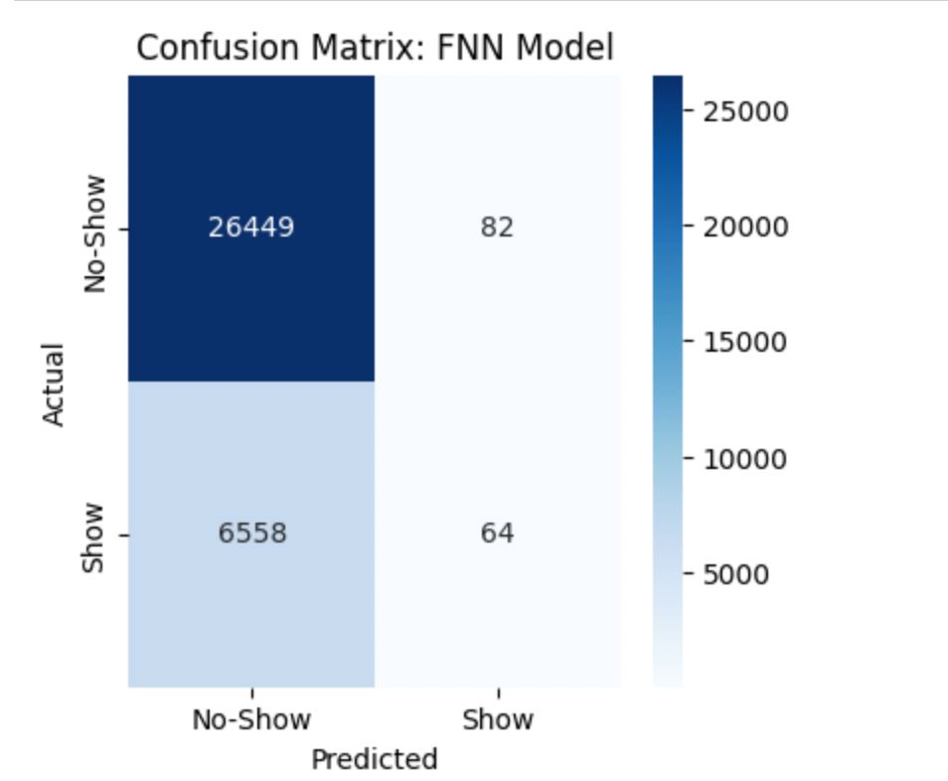 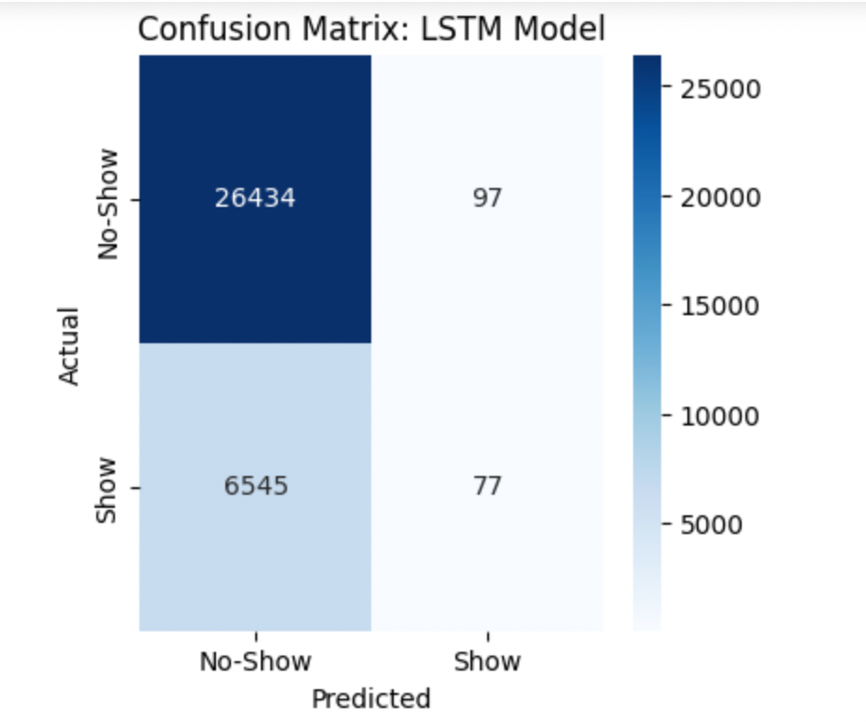

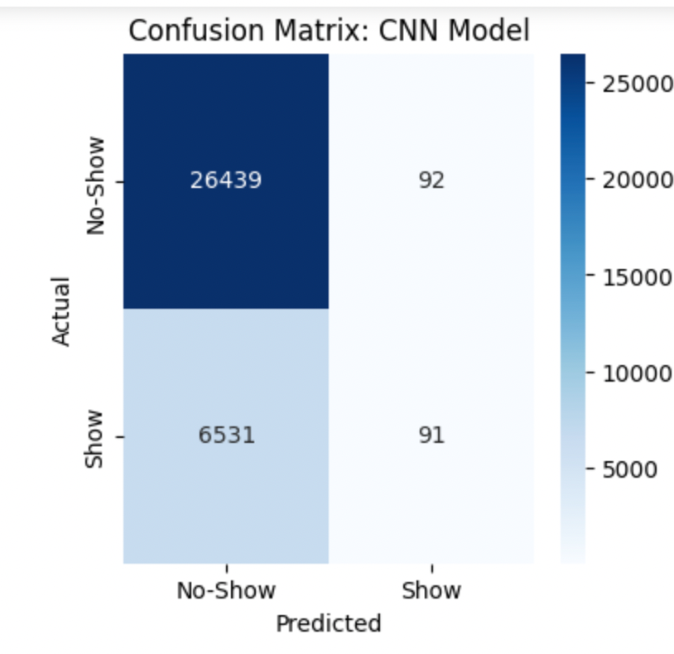

### ****Classification Report:****

* + Precision, recall, F1-score, and support metrics were generated for each model, offering detailed performance insights.

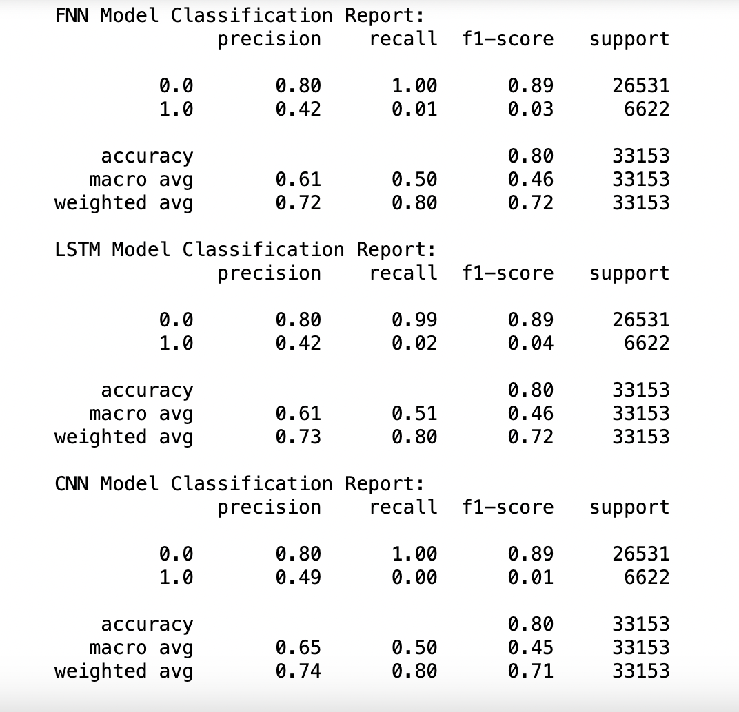

### ****ROC Curve and AUC:****

* + Calculated ROC-AUC values to visualize the trade-off between sensitivity and specificity:

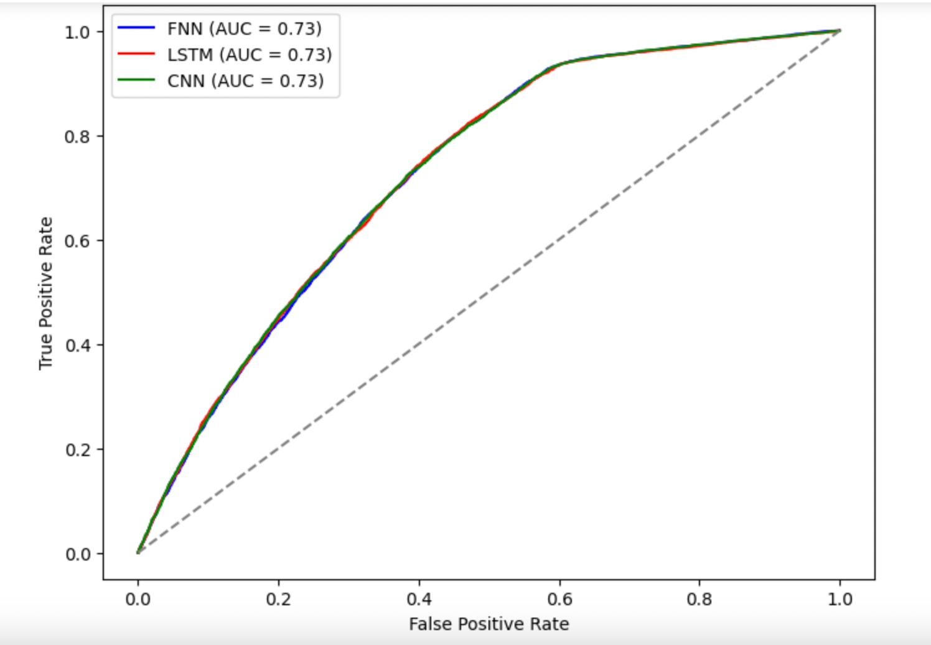

This ROC (Receiver Operating Characteristic) curve compares the performance of three models — **FNN (Feedforward Neural Network)**, **LSTM (Long Short-Term Memory Network)**, and **CNN (Convolutional Neural Network)**

* **True Positive Rate (TPR)** is plotted against the **False Positive Rate (FPR)** for varying threshold values.
* The **AUC (Area Under the Curve)** for all three models is **0.73**, indicating that the models perform similarly in distinguishing between classes.
* The diagonal line represents random guessing (AUC = 0.5). All three curves are above this line, showing that the models perform better than random.

### ****6. Visualizations****

### ****Training and Validation Curves:****

* + Epoch-wise plots of accuracy and loss were generated for all models, helping identify overfitting or underfitting.

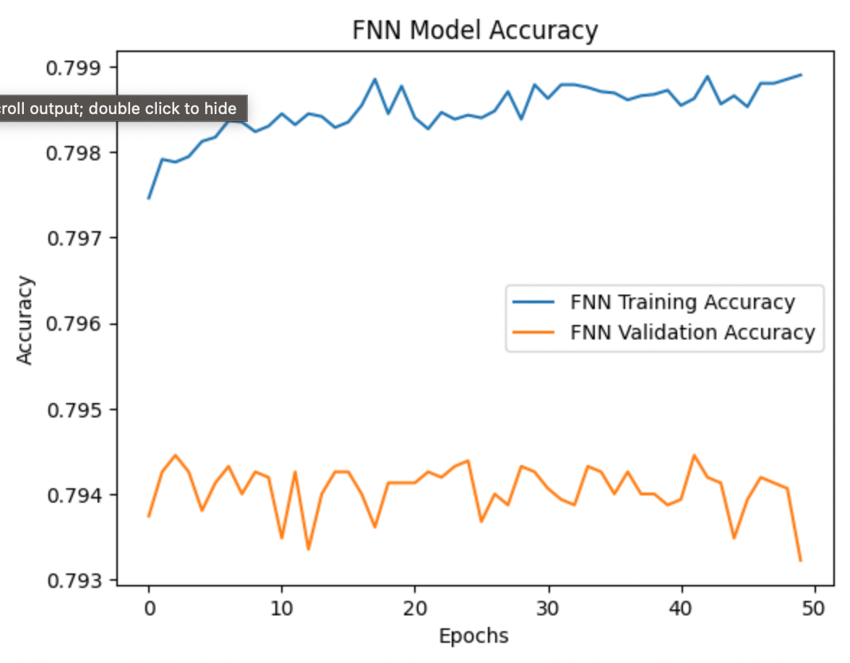 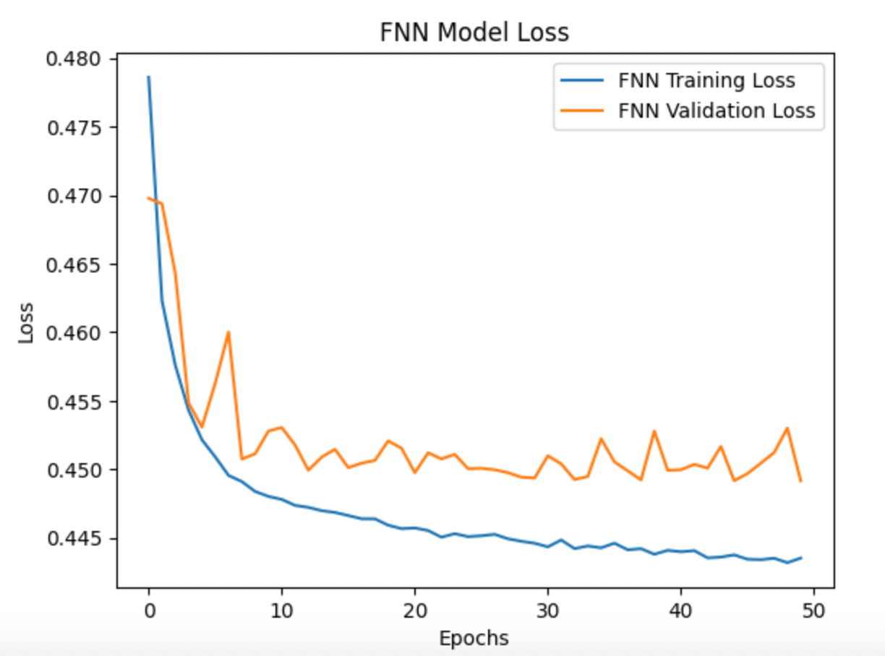

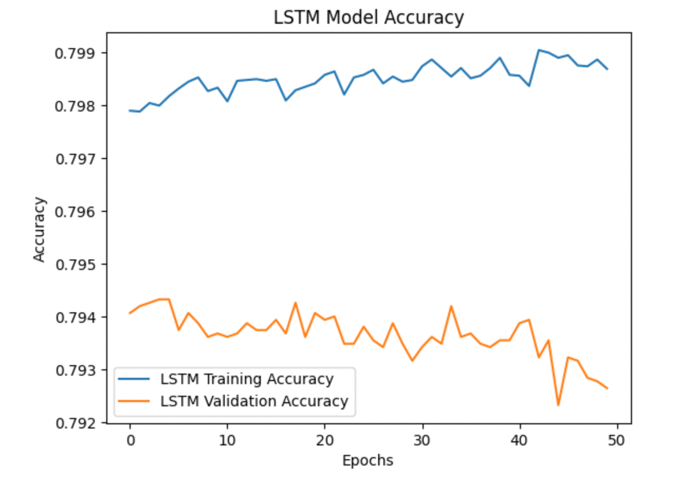 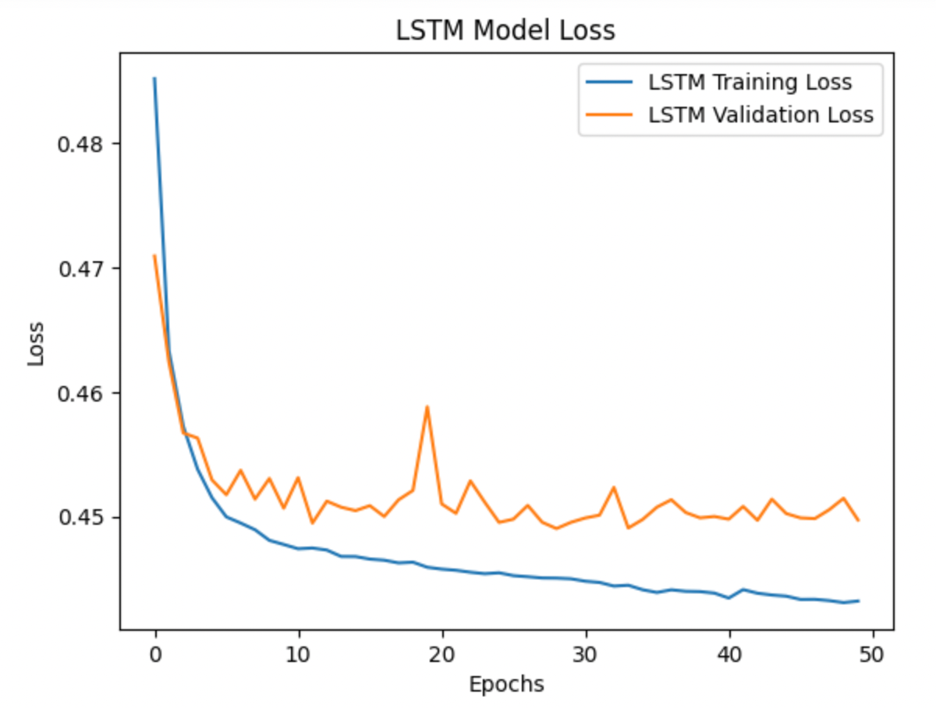

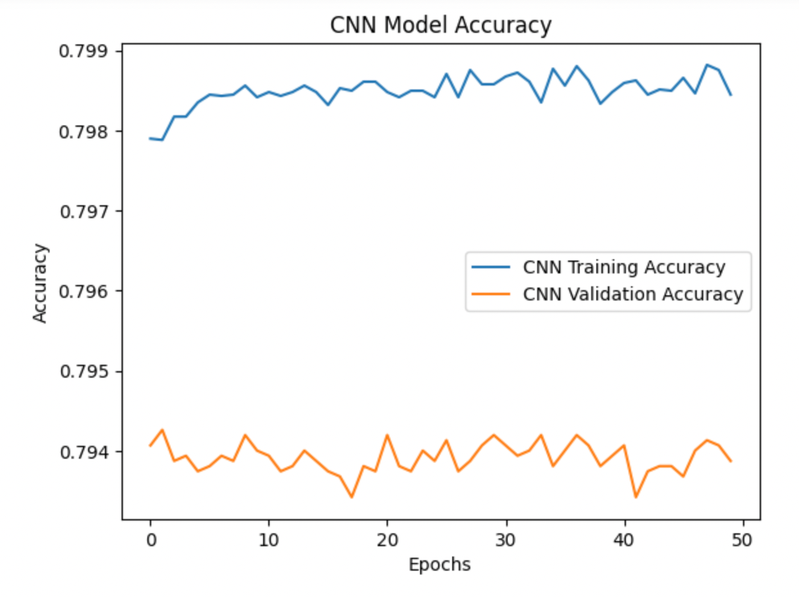 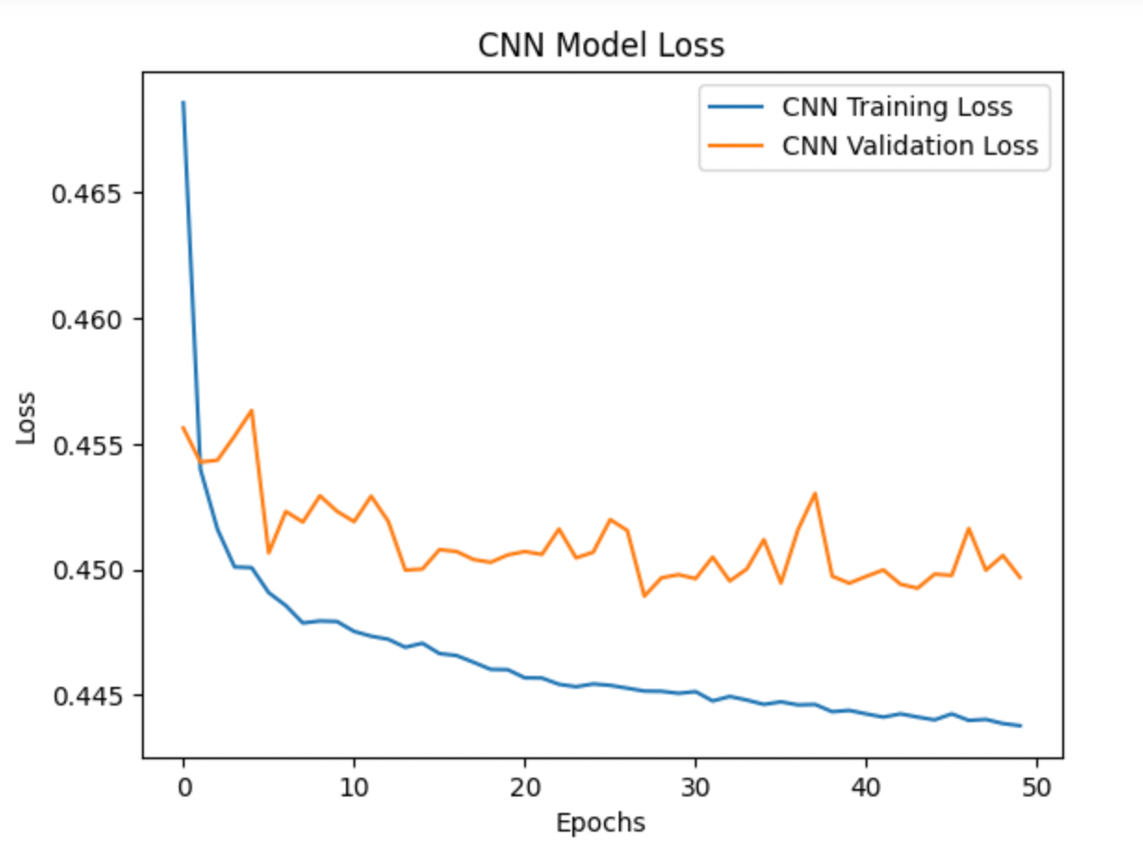

### ****7. Key Observations****

* All models achieved comparable results, with CNN marginally outperforming others.
* Overfitting was mitigated using techniques like validation split and batch training.
* Visualization methods (ROC curves, violin plots, and confusion matrices) provided actionable insights for further model tuning.

### ****8.Insights and Recommendations****

### ****Insights:****

1. **Waiting Time:** Longer waiting times increase the likelihood of no-shows.
2. **SMS Reminders:** Effective in reducing no-show rates.
3. **Age:** Younger patients are more likely to miss appointments.
4. **Neighborhood Patterns:** Some neighborhoods have consistent no-show behavior.

### ****Recommendations:****

1. **Reduce Waiting Times:** Streamline scheduling to minimize delays.
2. **SMS Campaigns:** Expand SMS reminder usage, especially in high-risk neighborhoods.
3. **Targeted Interventions:** Focus on young patients and neighborhoods with high no-show rates.
4. **Flexible Scheduling:** Introduce rescheduling options to avoid missed appointments.

### ****9.Conclusion****

This analysis provides actionable insights into factors influencing appointment attendance. By addressing the identified trends, healthcare providers can improve efficiency and reduce no-show rates, ultimately enhancing patient care.

### ****YOU TUBE VIDEO URL’S****

### <https://youtu.be/b1H5YCINISs>

### <https://youtu.be/o05maypMEmI>